FOOTBALL - 5 Man Position Keys

KICKOFF
POSITIONS
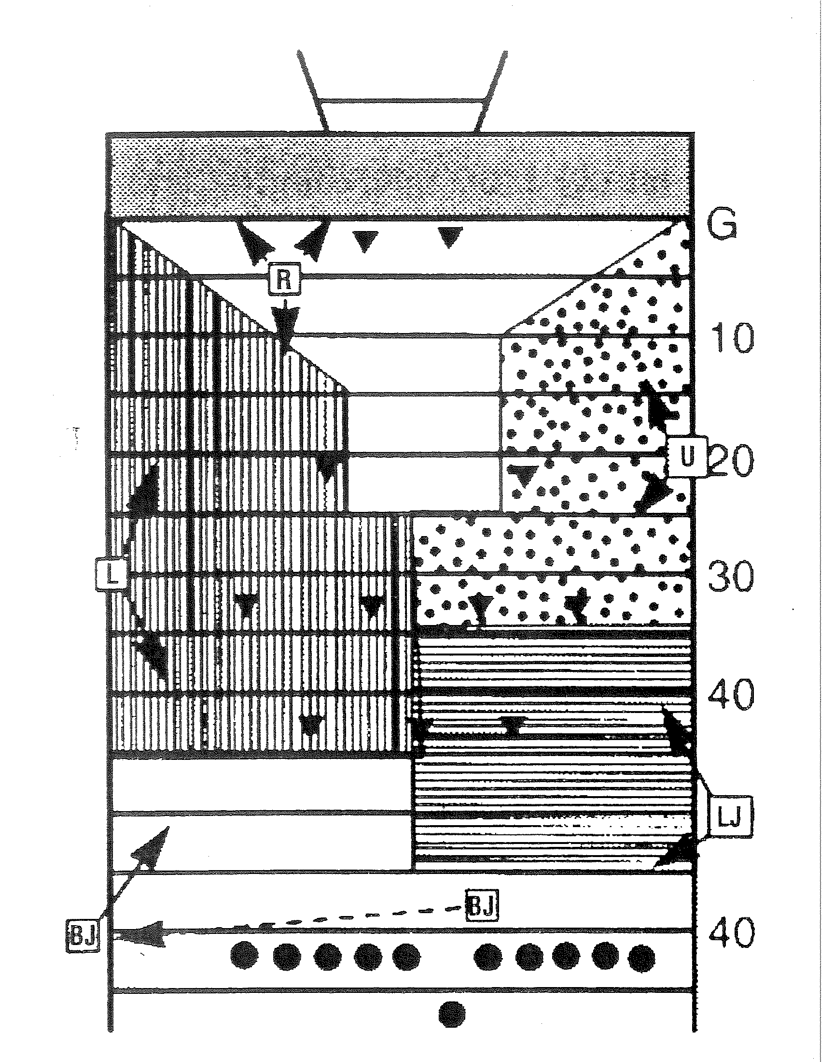

  - Referee
    - Goal line between hash mark & sidelines. Chain side.
    - Count R
    - Signal Kick. Rule on Touchback & momentum if caught inside five.
  - Umpire
    - 20 yard line. Opposite chains.
    - Count R
  - Linesman
    - 30 yard line. Chain side of field.
    - Count K
  - Line Judge
    - 50 yard line. Opposite chains.
    - Count K.
  - Back Judge
    - 40 yard line. Chain side. Control ball.
    - Count K.
    - Time 25 seconds
FIELD GOAL OR TRY
  - Referee
    - Facing holder, 1 yard behind, 2-3 yards to side.
    - Count K
    - Observe Kicker/holder
    - Be prepared to cover vacated side line
  - Umpire
    - Count K
    - Watch snapper.
    - Determine if ball crosses/recovered beyond neutral zone.
  - Linesman
    - Count K
    - Observe neutral zone.
    - If holder is facing your sideline, position behind goal in line with upright.
    - If on LOS, move in.
    - Judge upright, step in unison with BJ and signal.
    - Be prepared to rule on goal line.
  - Line Judge
    - Count R.
    - Observe neutral zone.
    - If holder is facing your sideline, position behind goal in line with upright.
    - If on LOS, move in.
    - Judge upright, step in unison with BJ and signal.
    - Be prepared to rule on goal line.
  - Back Judge
    - Count R.
    - Position behind goal in line with upright.
    - Judge upright and cross bar, step in unison with L or LF and signal.
    - Time 25 seconds
Remember ball remains live and is treated like a punt for field goal.
SCRIMMAGE KICK
  - Referee
    - Three to Four yard in front and five to seven yards outside kicking leg of kicker.
    - Count K
    - Watch for fouls behind line.
    - Line up kick in flight out of bounds.
  - Umpire
    - Count K
    - Watch snapper.
    - Determine if ball crosses/recovered beyond neutral zone.
    - Pivot toward LJ side and move toward return area observing players away from ball.
  - Linesman
    - Count R
    - Observe neutral zone.
    - Hold position until ball crosses neutral zone.
    - Move down field watch blocks and fair catch signals.
  - Line Judge
    - Count R
    - Observe neutral zone.
    - Move down field at the snap.
    - Watch blocks and fair catch signals.

  - Back Judge
    - Position on chain side in front of and to the side of the deepest receiver.
    - Count R.
    - Watch ball and deep receivers.
    - Time 25 seconds
    - Be ready to rule on first touching, fumble, muff, momentum, and touchback.
    - Bean bag end of kick.
INITIAL RECEIVER KEYS
  - The wing officials and back judge must determine which side of the line has the most eligible receivers > this is the strong side. (Motion can change strength)
  - Wing officials must indicate if player on end of line is back by extending their arm > be sure the other wing official and back judge have an opportunity to see your signal.

  - Linesman
    - If weak side, or equal strength > key on all eligible receivers on your side. Back judge will key to the line judge’s side.
    - If strong side > key on eligible receivers in back field. If trips > key on inside back.
  - Line Judge
    - If weak side > key on all eligible receivers on your side.
    - If strong side > key on eligible receivers in back field. If trips > key on inside track.
  - Back Judge
    - Determine strength; move to that side but not outside the hash marks.
    - If equal strength, key on player on end of line on Line Judge side.
    - Key on player on end of line on strong side.
    - If trips, key on two outside receivers.
Remember, these are initial keys. Your player responsibilities can change as the play develops. Do not focus exclusively on your primary plays.

MEASUREMENT
  - Referee - Rule on measurement. Signal down.
  - Umpire - Take forward chain and stretch when directed.
  - Linesman - Appropriately place clip on yard line.
  - Line Judge - Align linesmen so clip spot and front of chain are parallel with sideline.
  - Back Judge - Hold ball. Be on opposite side of press box.
- TIMING: Back Judge - Time 25 second, 1 minute timeouts, including scores.

